

**Topic: Peering**

**Create two VPC’s in different regions and connect the two VPC’S.**

**A)**

Step 1: Create VPC’s in two different regions by giving the names as myvpc1 & myvpc2.

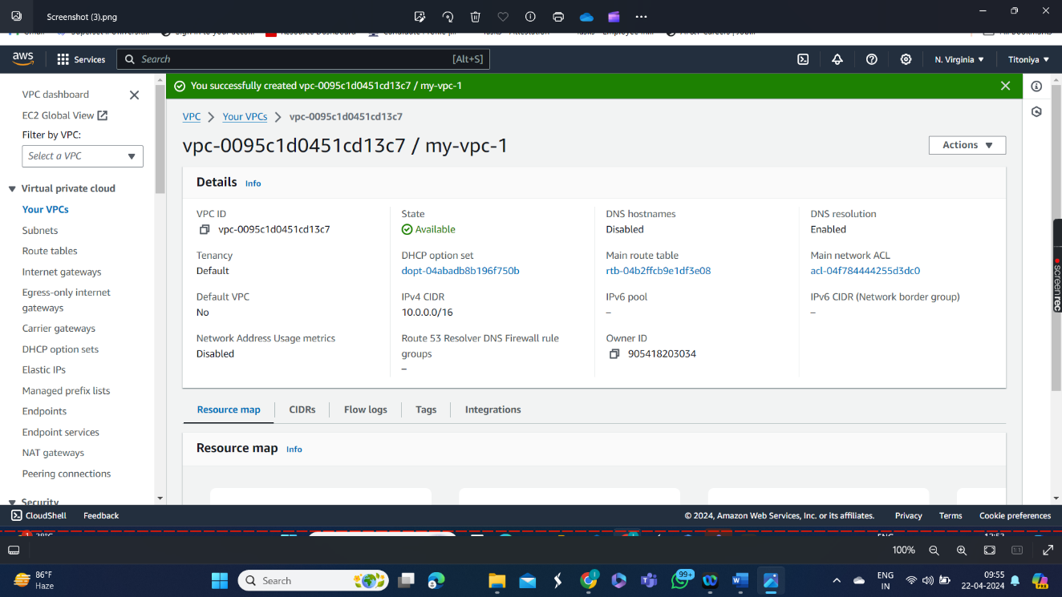

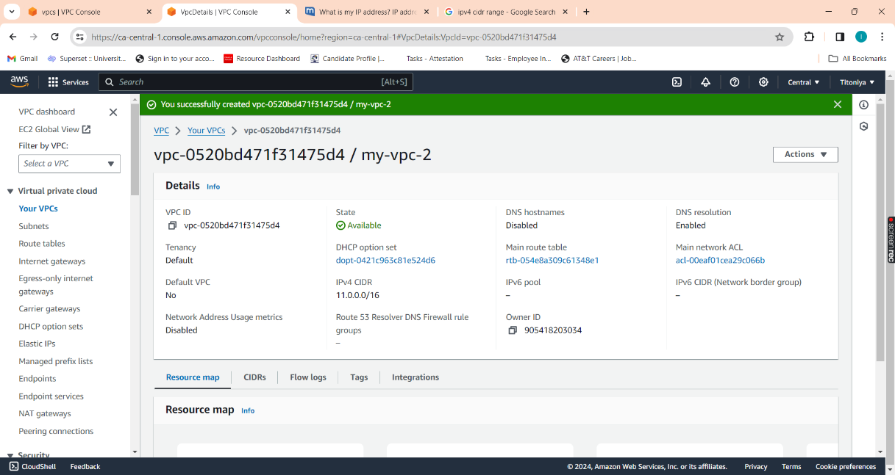

Step 2: Create subnets in two regions by giving the names as mysubent1 & mysubnet2.

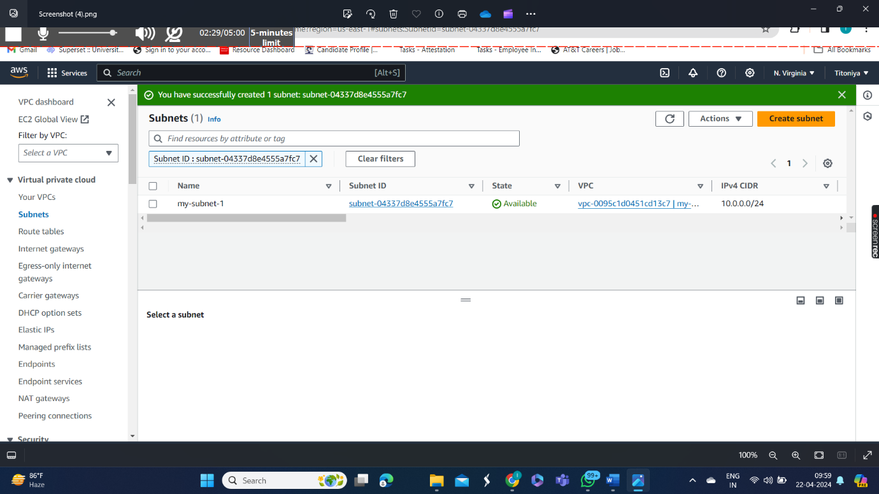

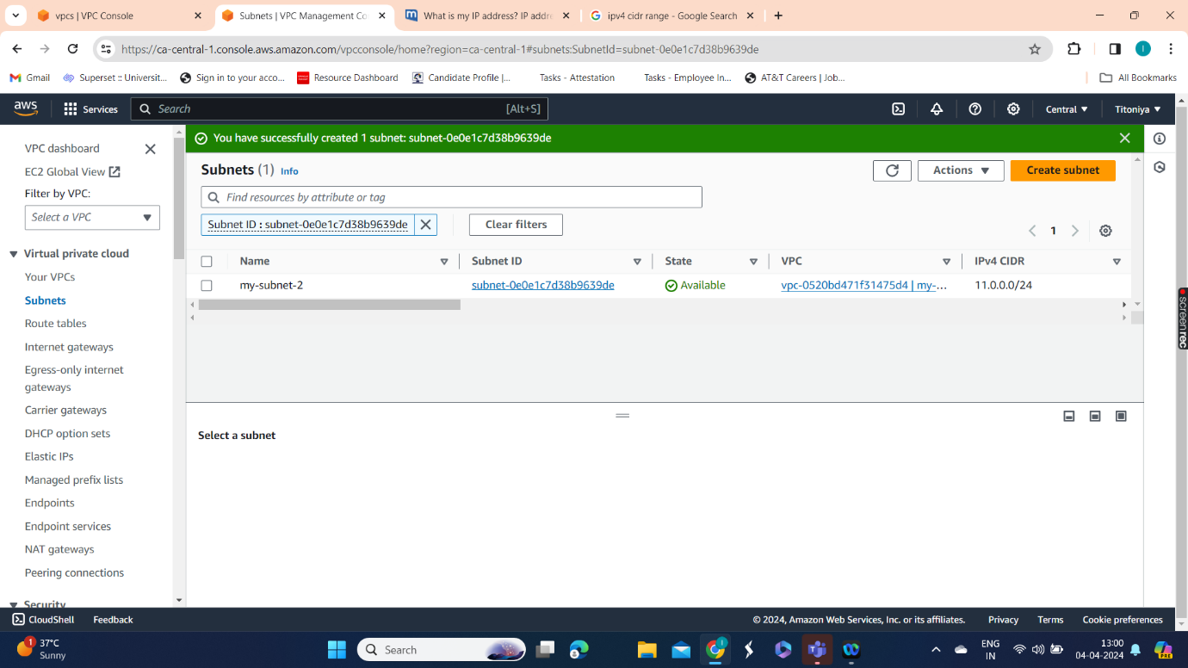

Step 3: Create two Internet gateways in two regions by giving the names as igw1 & igw2.

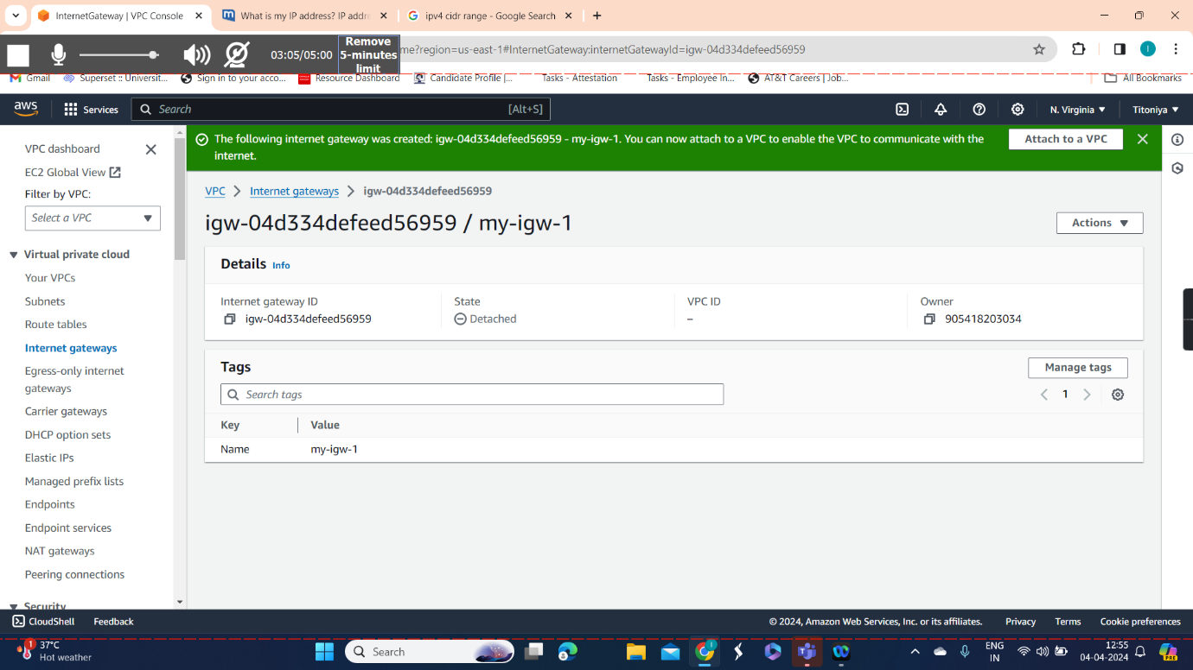

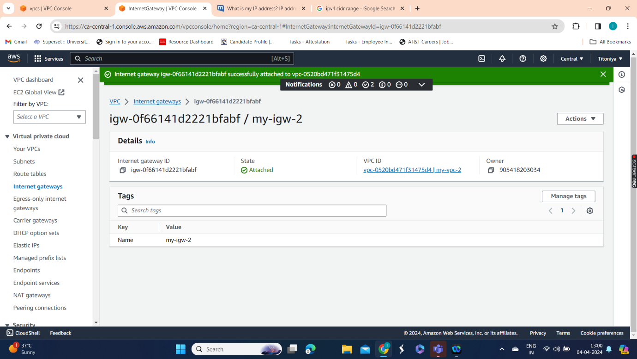

Step 4: Attach the both VPC’s to both the internet gateways.

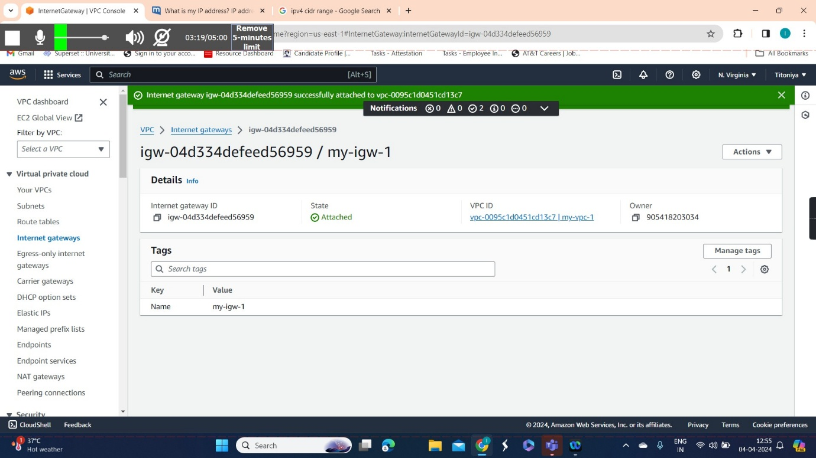

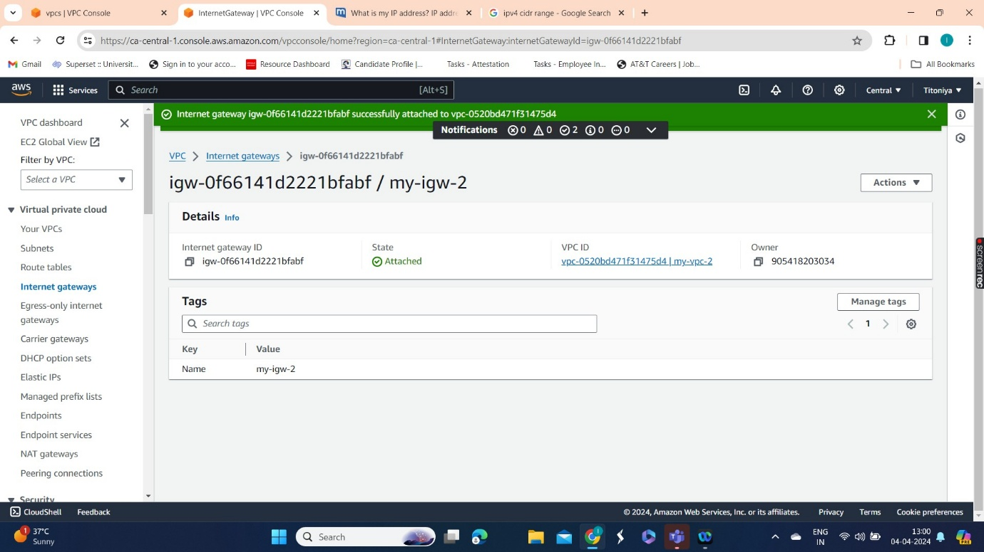

Step 5: Create route tables in two regions by giving the name as myroutetable1 & myroutetable2. And edit subnet associations for both the route tables and save.

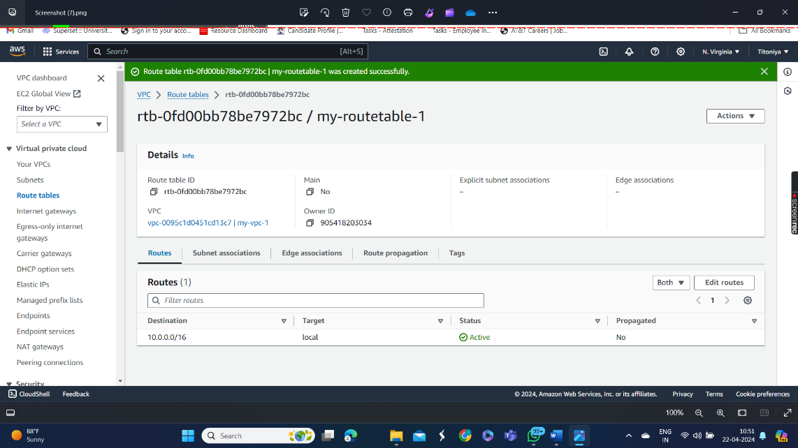

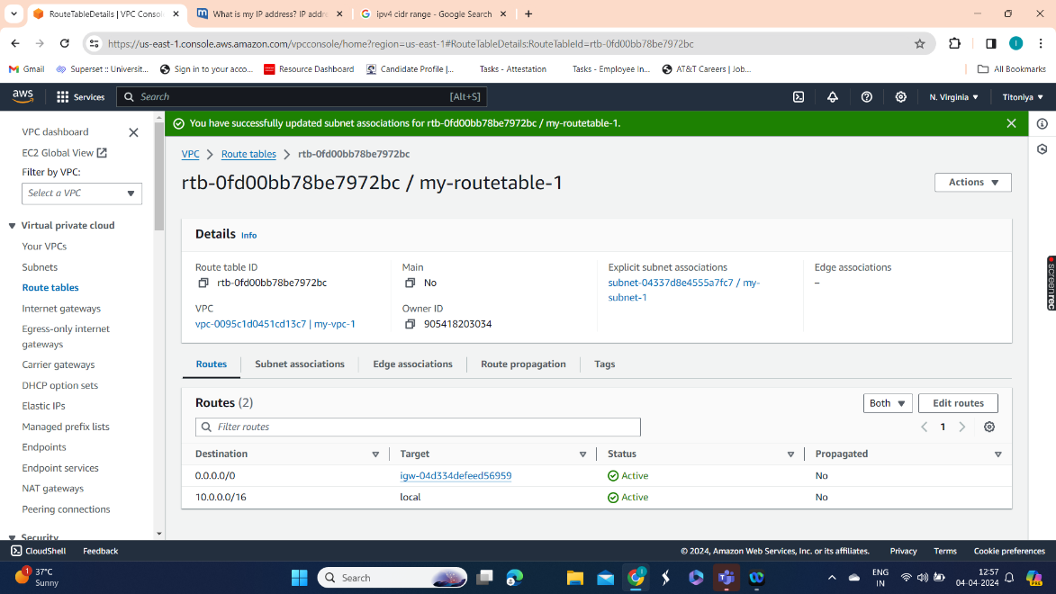

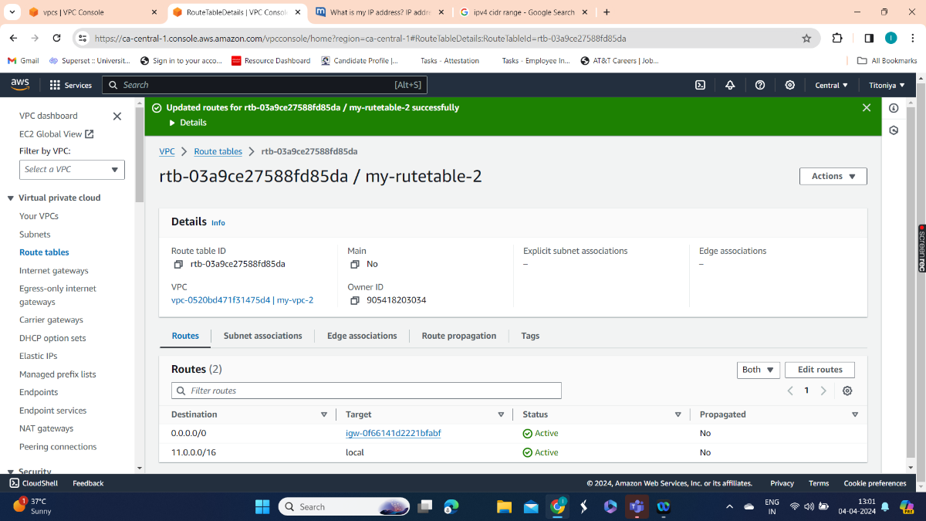

Step 6: Create EC2 instance in both the regions with keypair & connect the instance.

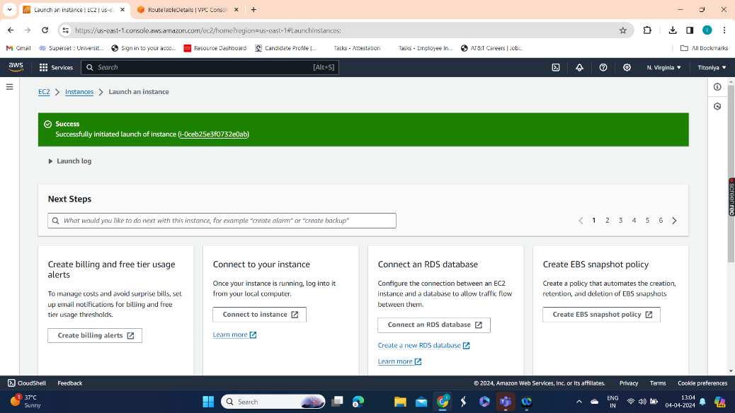

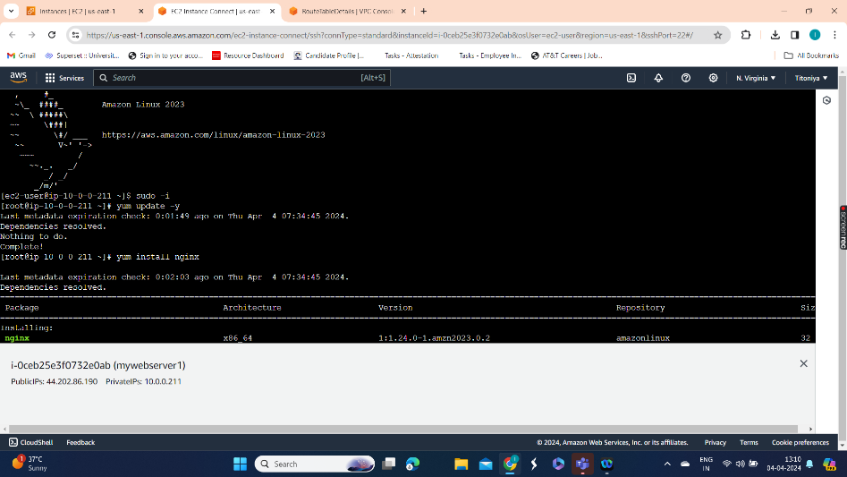

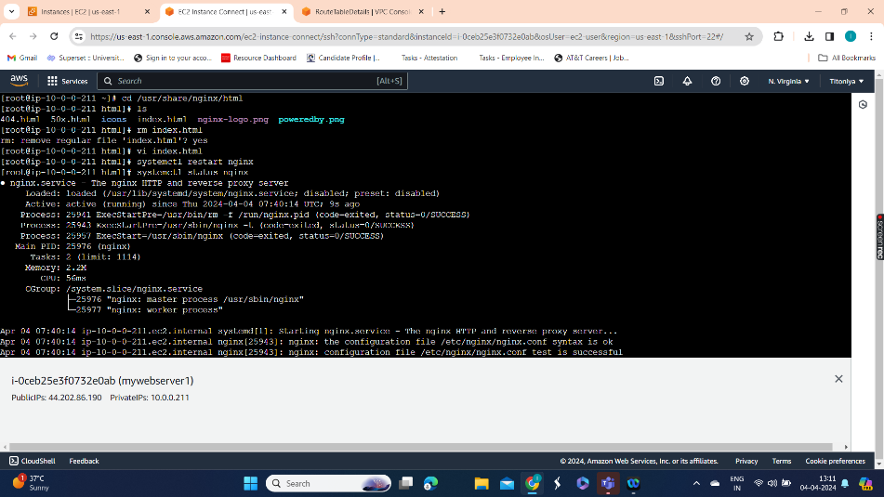

Step 7: Edit network settings and add security group.

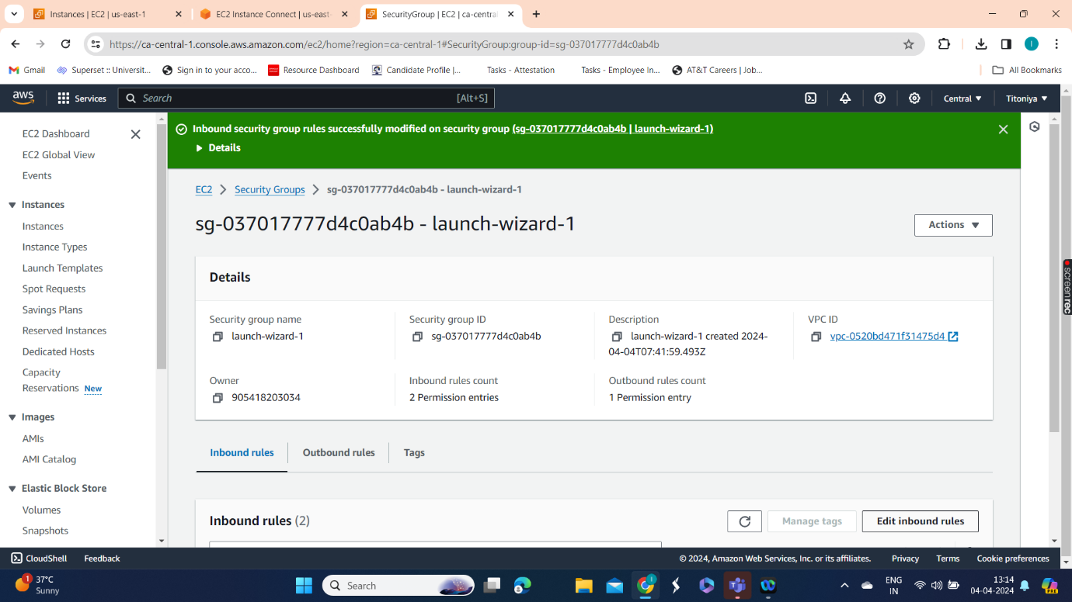

Step 8: Creating Peering connection in one region & accepting peering connection in another region.

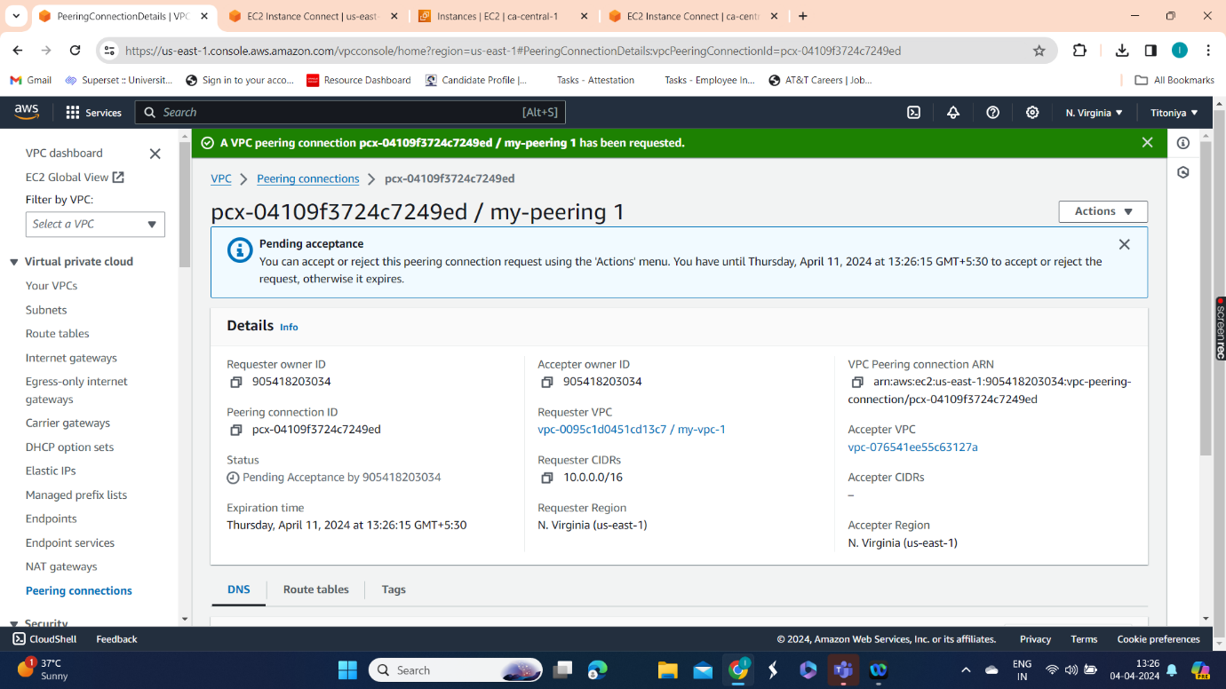

Step 9: Edit route to add peering connection with both the regions.

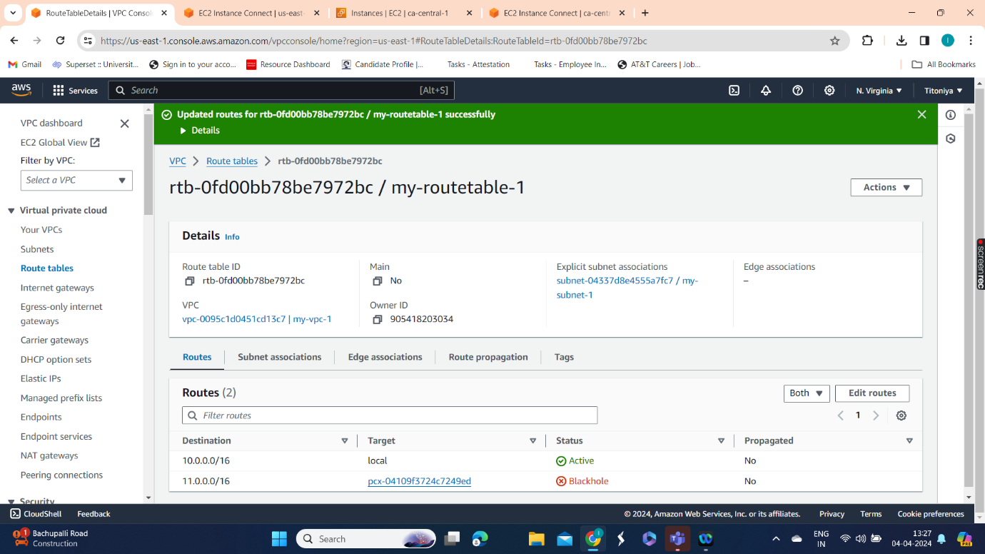

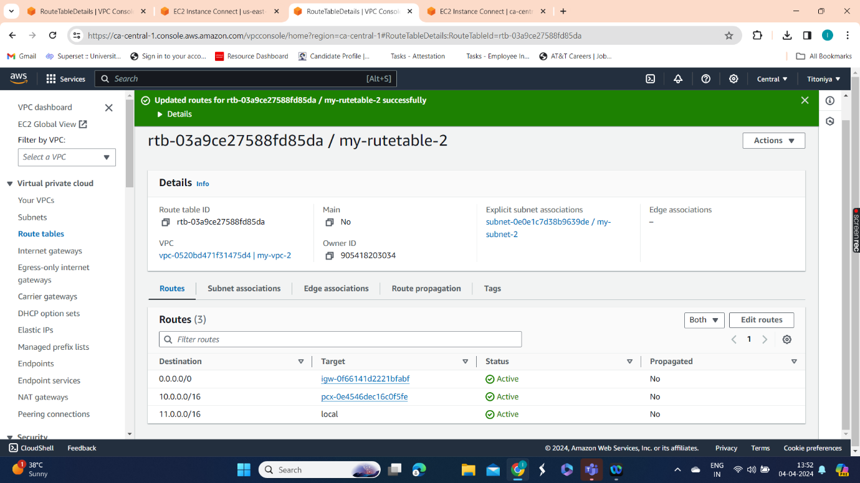

Step 10: Edit security groups in both the instances, & edit inbound rules and save.

Step 11: Checking with the private IP address in different regions.

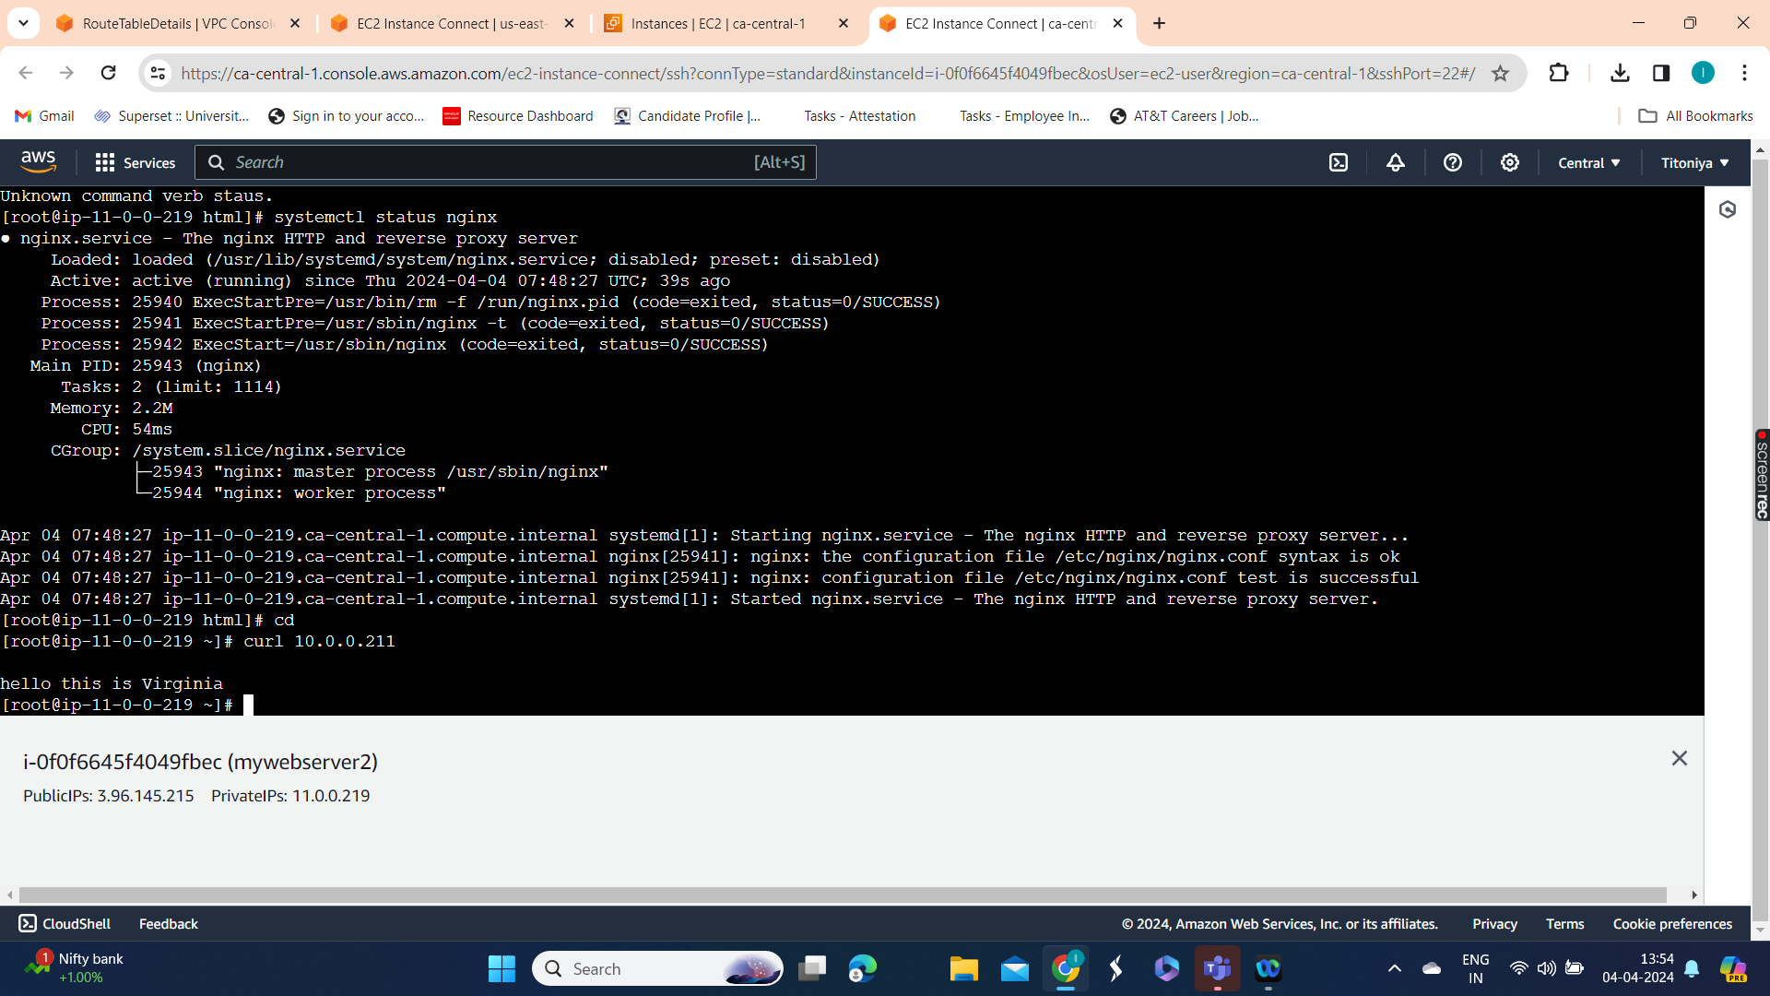

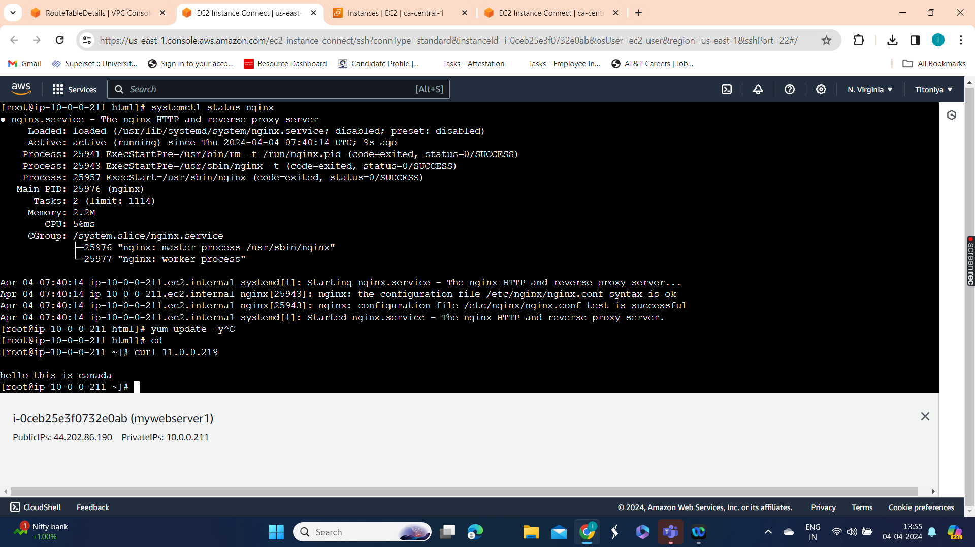

Hence Peering connection is established between 2 VPC’s in different regions.